**120A3051**

**Shreya Idate**

**Batch: E3**

**Experiment No: 2**

**AIM**: To learn Version Control System / Source Code Management, install git and create a GitHub account.

**THEORY**:

**Introduction to Version Control System:**

Version control, also known as source control, is the practice of tracking and managing changes to software code. Version control systems are software tools that help software teams manage changes to source code over time. As development environments have accelerated, version control systems help software teams work faster and smarter. They are especially useful for DevOps teams since they help them to reduce development time and increase successful deployments.

Version control software keeps track of every modification to the code in a special kind of database. If a mistake is made, developers can turn back the clock and compare earlier versions of the code to help fix the mistake while minimizing disruption to all team members.

Good version control software supports a developer's preferred workflow without imposing one particular way of working. Ideally it also works on any platform, rather than dictate what operating system or tool chain developers must use. Great version control systems facilitate a smooth and continuous flow of changes to the code rather than the frustrating and clumsy mechanism of file locking - giving the green light to one developer at the expense of blocking the progress of others.

Version control software is an essential part of the every-day of the modern software team's professional practices. Individual software developers who are accustomed to working with a capable version control system in their teams typically recognize the incredible value version control also gives them even on small solo projects.

**What is Git?**

By far, the most widely used modern version control system in the world today is Git. Git is a mature, actively maintained open source project originally developed in 2005 by Linus Torvalds, the famous creator of the Linux operating system kernel. A staggering number of software projects rely on Git for version control, including commercial projects as well as open source. Developers who have worked with Git are well represented in the pool of available software development talent and it works well on a wide range of operating systems and IDEs (Integrated Development Environments).

In addition to being distributed, Git has been designed with performance, security and flexibility in mind.

**Install Git on Windows:**

* Download the latest Git for Windows installer.
* When you've successfully started the installer, you should see the Git Setup wizard screen. Follow the Next and Finish prompts to complete the installation. The default options are pretty sensible for most users.

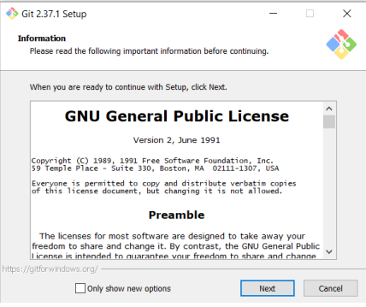

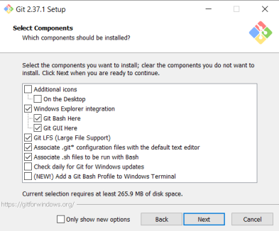

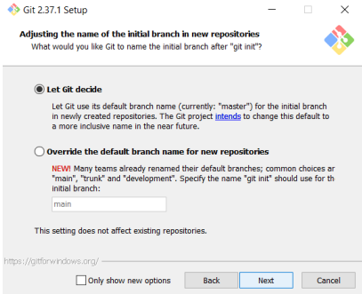

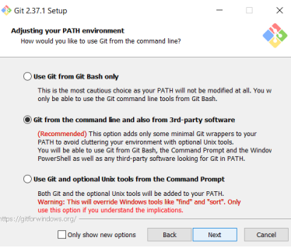

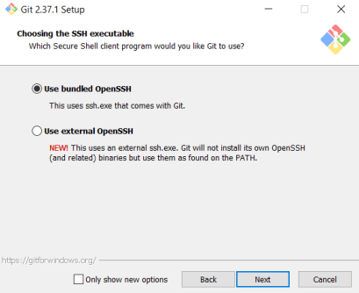

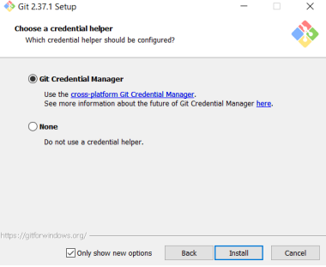

* Create your GitHub Account on https://github.com/join

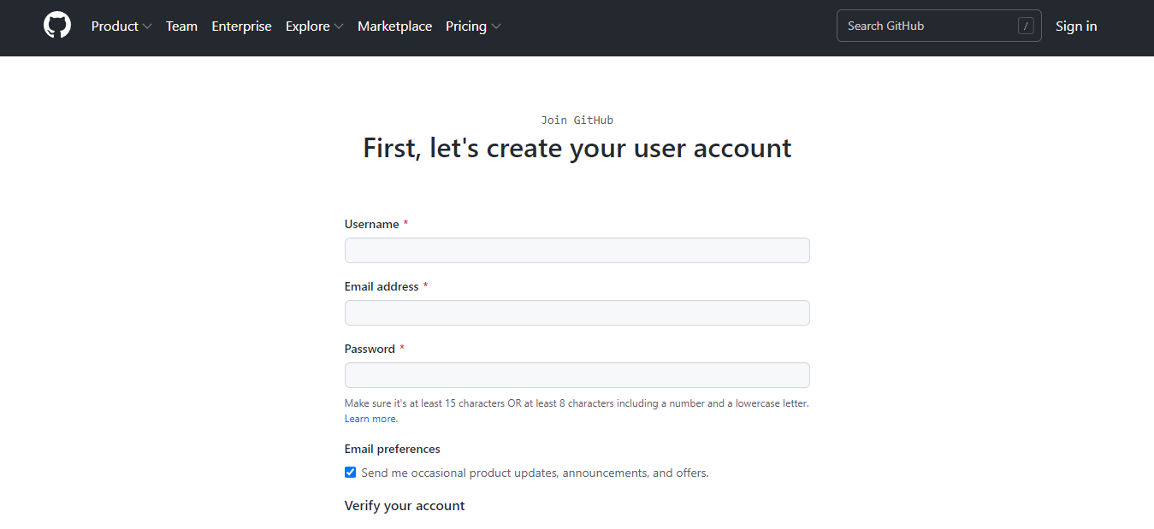

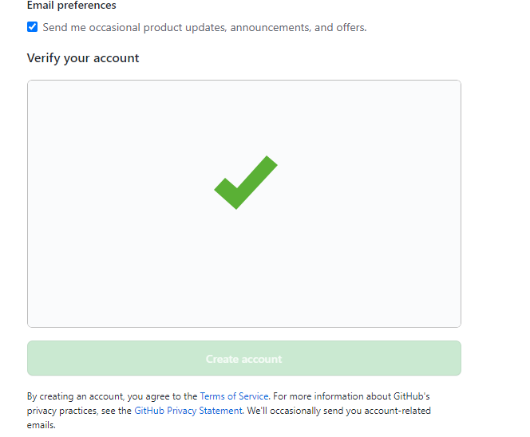

Login to your GitHub account:

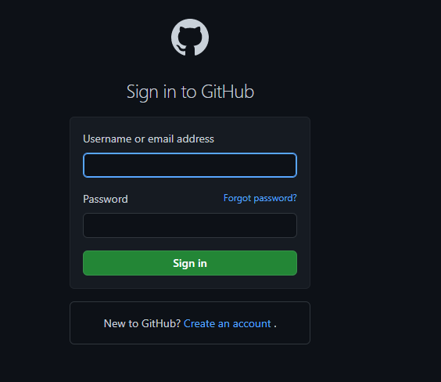

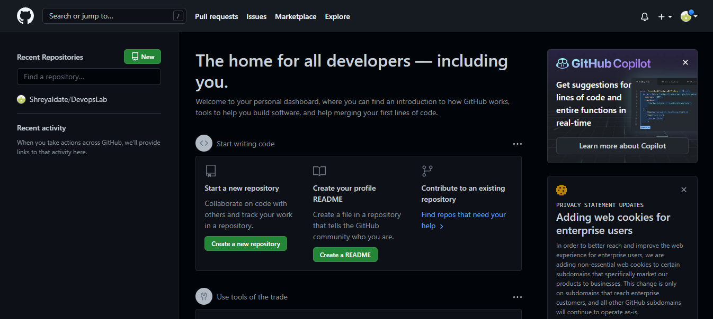

* Open a Command Prompt (or Git Bash if during installation you elected not to use Git from the Windows Command Prompt).
* Run the following commands to configure your Git username and email using the following commands, replacing Emma's name with your own. These details will be associated with any commits that you create:

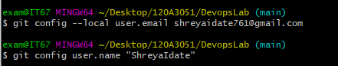

**CONCLUSION: S**uccessfully learned about Version Control Systems, git and GitHub.